

Project Title: Sportswear E-Commerce Website
Subject: Software Architecture Design

Cover page

Table of Contents
- Introduction
- Software Development Approach
- Architectural Design
- Technology Stack
- Requirements Modeling
- Main Flows
- Static Modeling
- Database Design
- Dynamic Modeling

1. Introduction
1.1 Context:
With the rapid growth of online shopping, customers increasingly prefer purchasing sportswear through digital platforms instead of visiting physical stores. However, many small and medium-sized sportswear retailers lack a complete e-commerce system and mainly rely on social media platforms, which leads to poor order management, limited customer support, and low automation.
Customers expect convenient product browsing, online payment, order tracking, and reliable product reviews before making purchasing decisions. Meanwhile, store owners require efficient tools to manage products, orders, and customer feedback.
Therefore, there is a strong demand for a dedicated e-commerce platform specialized in selling sportswear with intelligent customer support features.
1.2 Proposed solution:
The proposed solution is a web-based e-commerce system focused on selling sportswear products. The system provides core shopping functionalities such as product browsing, shopping cart, online payment, and order management. In addition, intelligent features such as an AI-based product classification module and a chatbot for product recommendation are integrated to improve customer experience and automate customer support.
The system is implemented as a web application using ReactJS for the frontend and Spring Boot for the backend, following a layered and modular monolithic architecture.
1.3 Objectives:
The main objectives of the system are:
  - To provide a user-friendly platform for customers to purchase sportswear online.
  - To support secure online payment and order tracking.
  - To allow customers to evaluate products through a review and rating system.
  - To assist customers in finding suitable products using chatbot-based recommendations.
  - To design a maintainable and extensible software architecture following software engineering principles.
  - To demonstrate the application of architectural design concepts learned in the course.
1.4 Scope:

Included Features
The project focuses on the following main functional areas:
- Purchase management: product browsing, shopping cart, checkout, and payment.
- Chatbot: automated customer support and product recommendation.
- Order status management: tracking order progress and notifications.
- Product review management: rating and reviewing purchased products.
- Admin management: managing products and orders.

Excluded Features
To keep the project scope suitable for a 10-week academic project, the following features are excluded:
  - Mobile application development.
  - Complex warehouse and inventory management systems.
  - Real-time logistics and shipping provider integration.
  - Advanced business analytics and recommendation systems.
1.5 Functional requirements:
The main functional requirements of the system include:
- User registration and authentication.
- Product listing and detailed product information display.
- Search and filtering of sportswear products.
- Adding products to shopping cart and updating cart contents.
- Checkout and online payment via VNPay or Momo (simulated integration).
- Creating and managing customer orders.
- Viewing and tracking order status.
- Submitting product ratings and reviews.
- Viewing reviews of other customers.
- Chatbot interaction for product suggestion and customer inquiries.
- Admin functionalities for product and order management.
2. Software Development Approach
2.1 SDLC Model:
The Agile development model was applied to this project. The system was developed through several short cycles – each lasting 2 weeks – delivering a set of functional features. This approach was suitable because the project requirements had a certain degree of flexibility and could be refined during development based on feedback and technical feasibility.
Agile development also allows the team to prioritize core functionalities such as purchase flow and order management before implementing advanced features like chatbot integration.
2.2 Development Process:
The development process consists of the following phases:
- Planning: defining project scope, identifying main flows, selecting technology stack.
- Analysis: collecting functional and non-functional requirements, identifying actors and use cases.
- Design: designing system architecture, database schema, and UML diagrams.
- Implementation: developing frontend and backend modules according to the design.
- Testing: performing unit testing, API testing, and integration testing.
- Deployment: packaging the system using Docker and deploying locally.
- Maintenance: fixing defects and improving performance and usability.
Each iteration goes through these phases with increasing system completeness.
3. Architectural Design
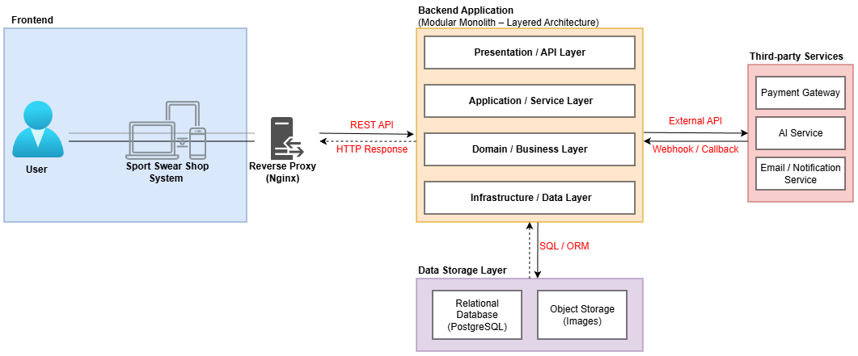
3.1 Chosen Architecture Style:
The system adopts a Layered Architecture combined with a Modular Monolithic structure.

Layered Architecture
The backend system is organized into the following layers:
- Presentation Layer: REST controllers handling HTTP requests and responses.
- Application Layer: DTOs and request validation.
- Business Layer: service classes containing business logic.
- Data Access Layer: repositories interacting with the database using JPA.
This separation improves maintainability and testability by clearly dividing responsibilities.

Modular Monolith
Although the system is deployed as a single application, it is internally divided into functional modules based on business domains, such as:
- Product Module
- Order Module
- Review Module
- Chatbot Module
- Authentication Module
Each module contains its own controllers, services, and repositories, which reduces coupling and allows easier migration to microservices in the future if required.
3.2 Deployment Diagram:
Logical Deployment Diagram
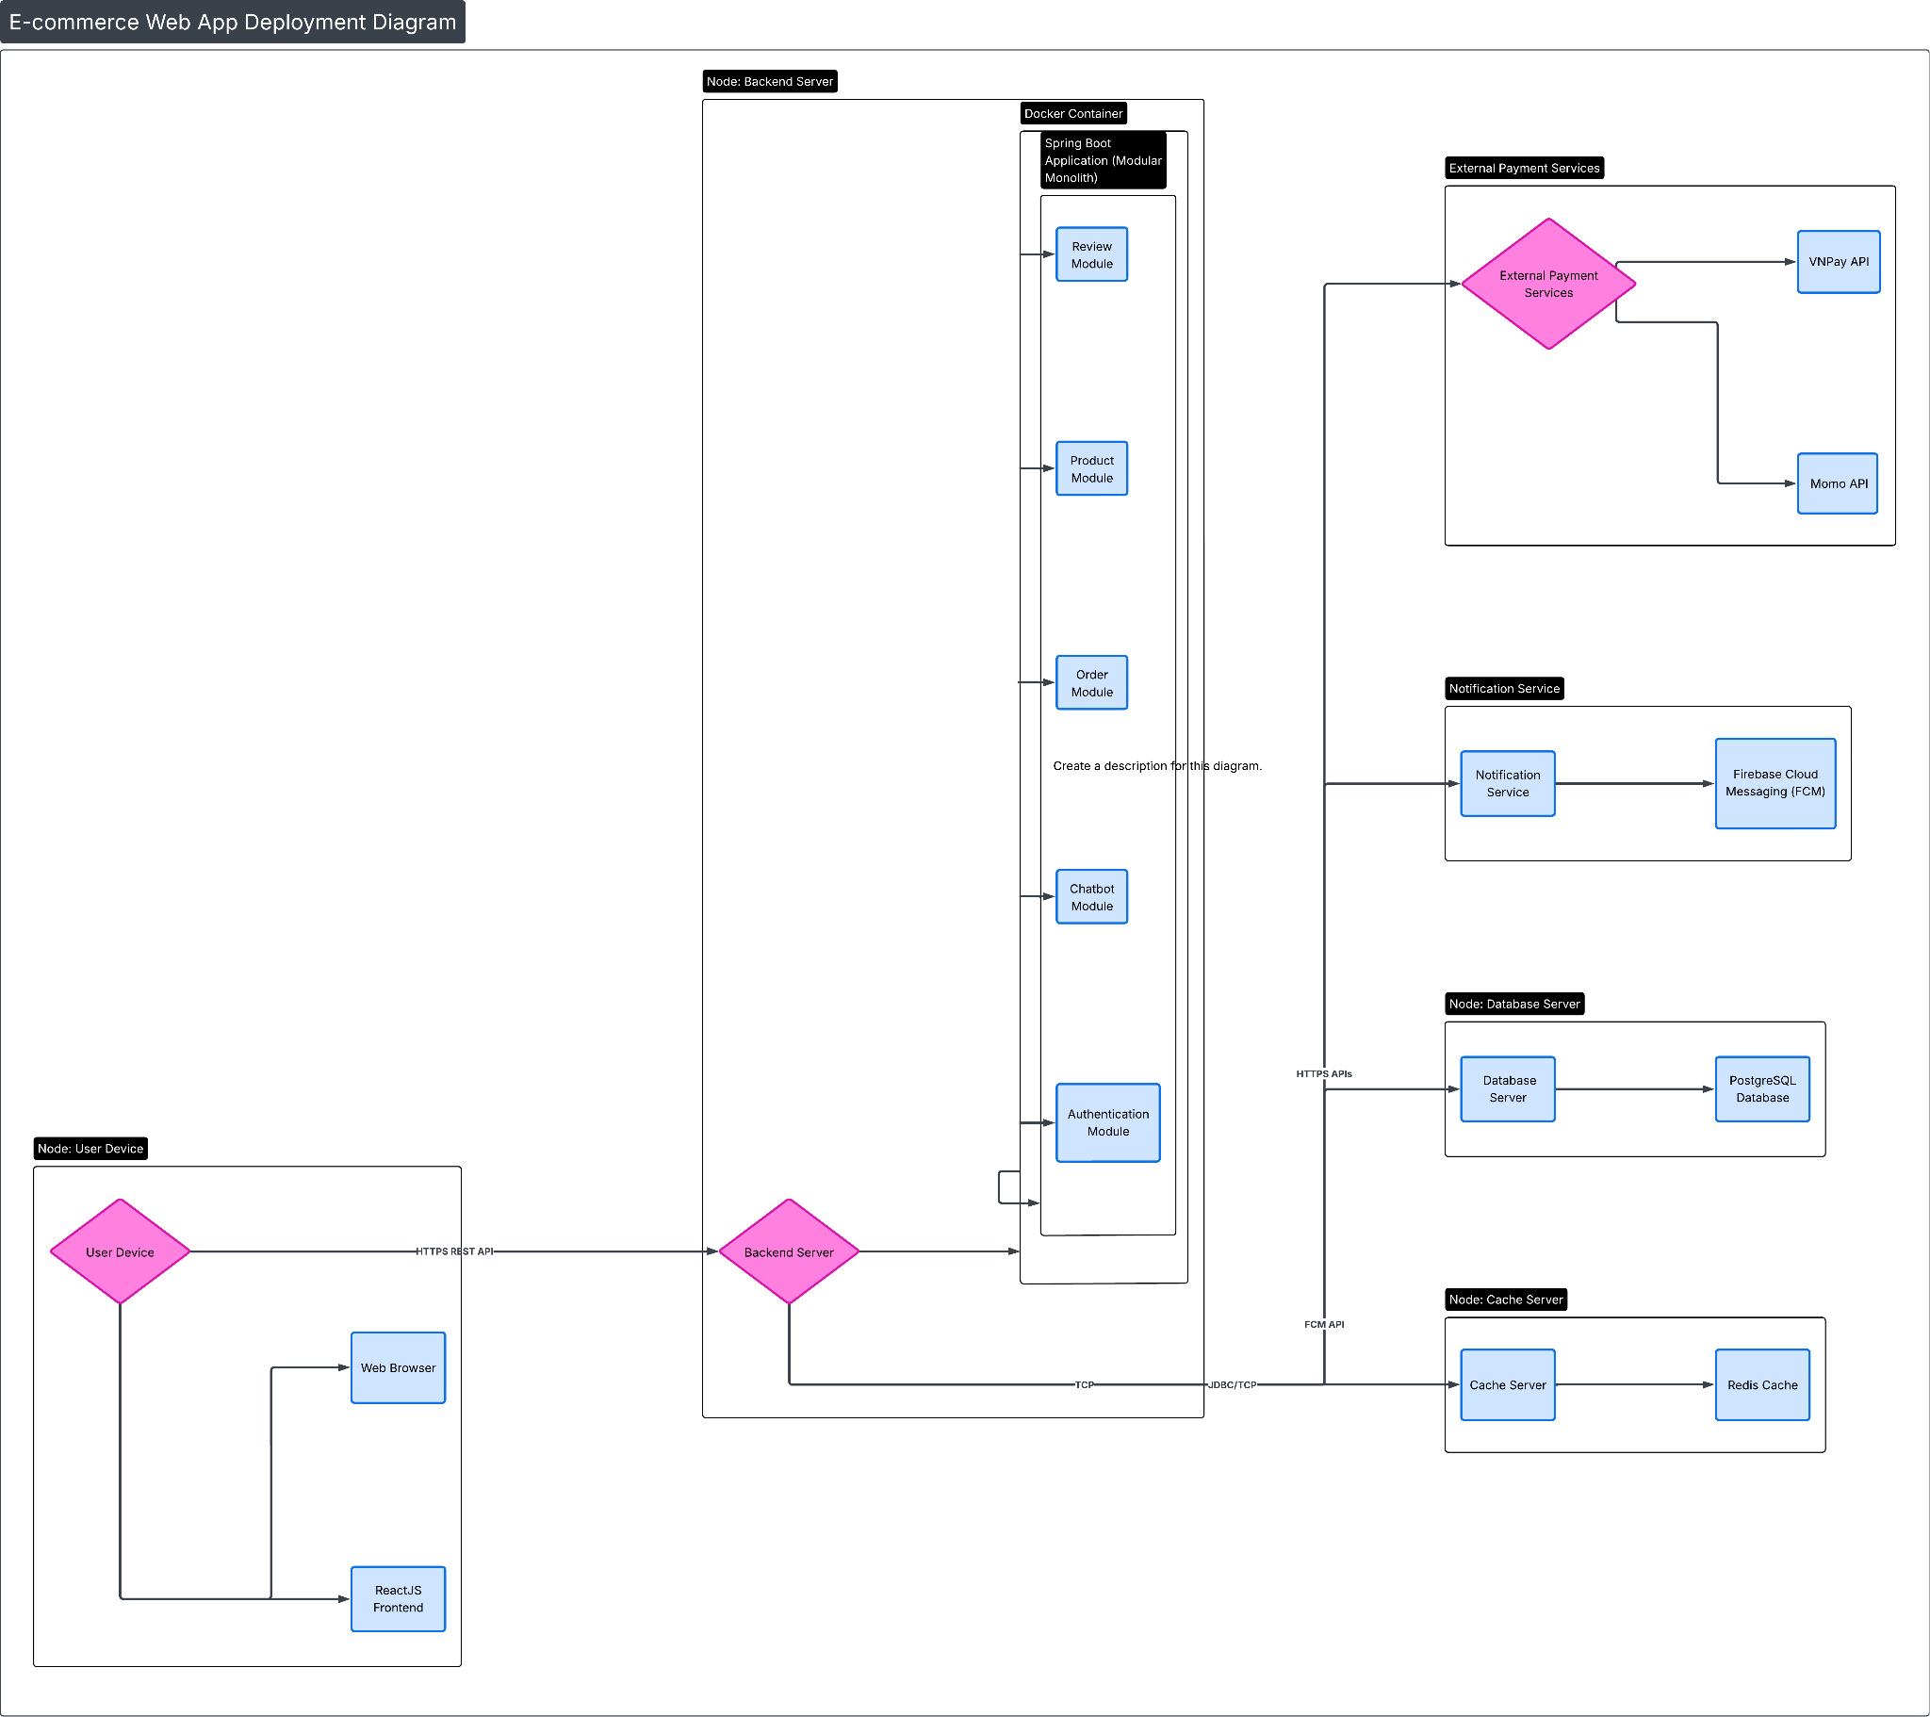
https://byvn.net/7GUJ

4. Technology Stack
4.1 Programming Language(s):
- Java (backend)
- ReactJS(frontend)
4.2 Frameworks/Libraries:
- Spring Boot for backend development
- Spring Security for authentication and authorization
- ReactJS for frontend user interface
- JPA/Hibernate for database access
4.3 Database:
- PostgreSQL as the relational database management system
- Redis for caching session data and frequently accessed product information
4.4 Tools:
- Git for version control
- Docker for containerization
- Swagger / OpenAPI for API documentation
- JUnit for backend unit testing
- Postman for API testing
5. Requirements Modeling
5.1 Actors: Identify key external users/systems.

No. | Actor | Description
1 | Registered User | Write Review, Manage Addresses, View Order Status, View Order History, AI Chatbot Interaction, Search Products, Purchase Management.
2 | Admin | Review/Rating Management, Respond to Review, AI Product Classification,Update Order Status
3 | Shipper | Update Order Status
4 | Guest | AI Chatbot Interaction, Search Products, Purchase Management.

5.2 Use Case Diagram: Provide one overall diagram.
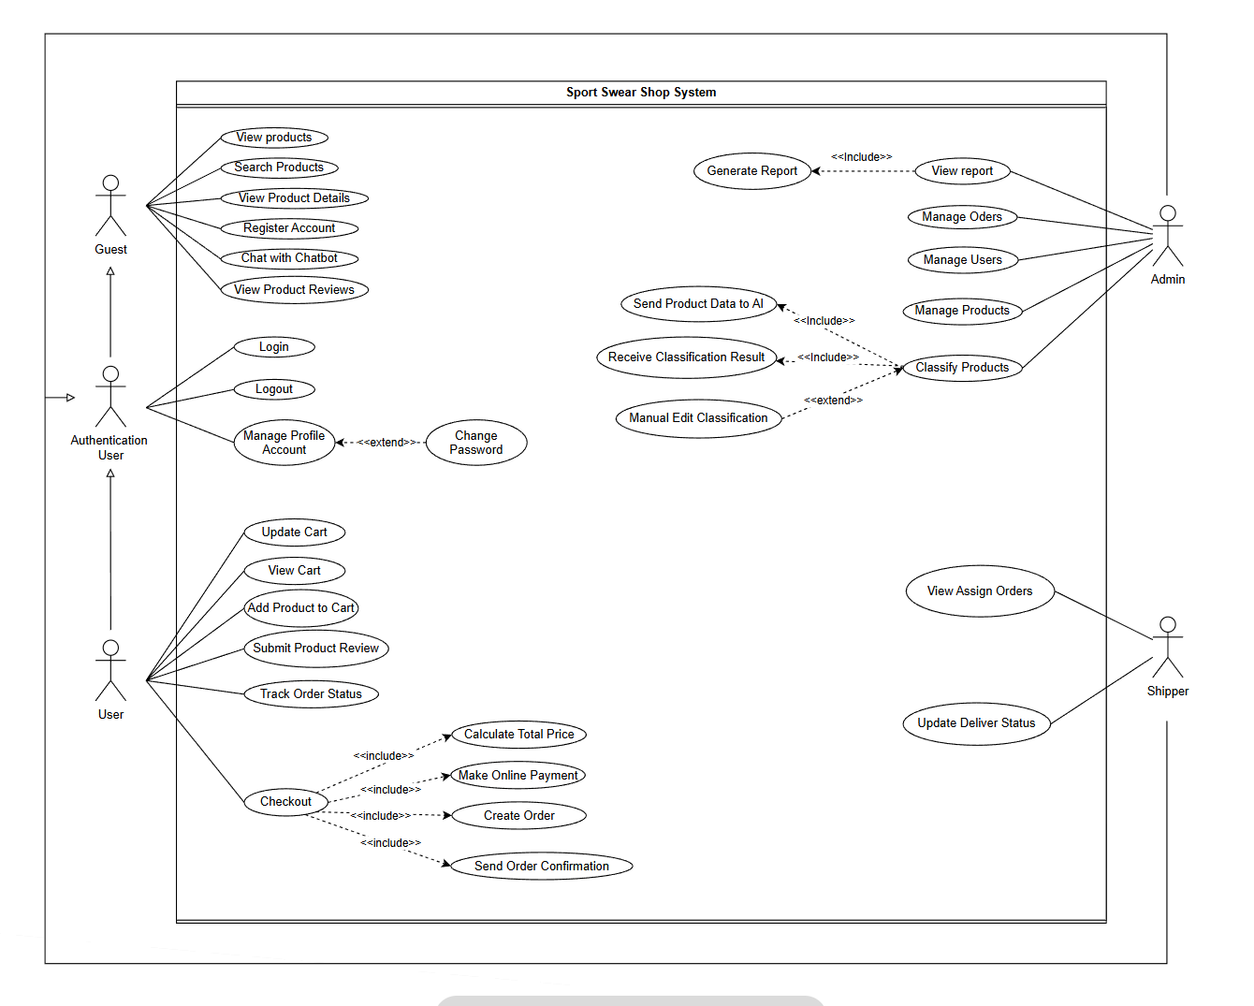

USE CASE TABLE – SPORT SWEAR SHOP SYSTEM
ID | Use Case | Actor | Description
UC01 | View Products | Guest | Guest views the list of available products in the system.
UC02 | Search Products | Guest | Guest searches for products by name, category, or keywords.
UC03 | View Product Details | Guest | Guest views detailed information of a selected product.
UC04 | Register Account | Guest | Guest registers a new account to become a registered user.
UC05 | Chat with Chatbot | Guest | Guest sends questions and receives product recommendations from the AI chatbot.
UC06 | View Product Reviews | Guest | Guest views reviews and ratings of products from other users.
UC07 | Login | Authentication User | User logs into the system using registered credentials.
UC08 | Logout | Authentication User | User logs out from the system.
UC09 | Manage Profile Account | Authentication User | User updates personal profile information.
UC10 | Change Password | Authentication User | User changes account password (extends Manage Profile Account).
UC11 | Add Product to Cart | User | User adds selected products to the shopping cart.
UC12 | View Cart | User | User views products currently in the shopping cart.
UC13 | Update Cart | User | User updates quantities or removes products from the cart.
UC14 | Submit Product Review | User | User submits a review and rating for a purchased product.
UC15 | Track Order Status | User | User tracks the current status of placed orders.
UC16 | Checkout | User | User performs checkout to place an order and make payment.
UC17 | Calculate Total Price | System | System calculates the total price of the order (included in Checkout).
UC18 | Make Online Payment | User | User makes online payment for the order.
UC19 | Create Order | System | System creates a new order after successful payment.
UC20 | Send Order Confirmation | System | System sends order confirmation to the user.
UC21 | Manage Orders | Admin | Admin views, updates, and processes customer orders.
UC22 | Manage Users | Admin | Admin manages user accounts in the system.
UC23 | Manage Products | Admin | Admin adds, updates, or deletes product information.
UC24 | View Report | Admin | Admin views system reports and statistics.
UC25 | Generate Report | System | System generates reports based on collected data.
UC26 | Classify Products | Admin | Admin uses AI to classify products into categories.
UC27 | Send Product Data to AI | System | System sends product data to AI service for classification.
UC28 | Receive Classification Result | System | System receives classification results from AI service.
UC29 | Manual Edit Classification | Admin | Admin manually adjusts AI classification results.
UC30 | View Assign Orders | Shipper | Shipper views assigned delivery orders.
UC31 | Update Delivery Status | Shipper | Shipper updates the delivery status of assigned orders.
5.3 Non-Functional Requirements:
- Security: JWT-based authentication, role-based authorization.
- Performance: caching using Redis to reduce database load.
- Scalability: modular design allows future system expansion.
- Reliability: transactional integrity for payment and order creation.
- Usability: responsive UI design for different devices.
- Maintainability: layered architecture and modular separation.

6. Main flows
6.1 Purchase Management
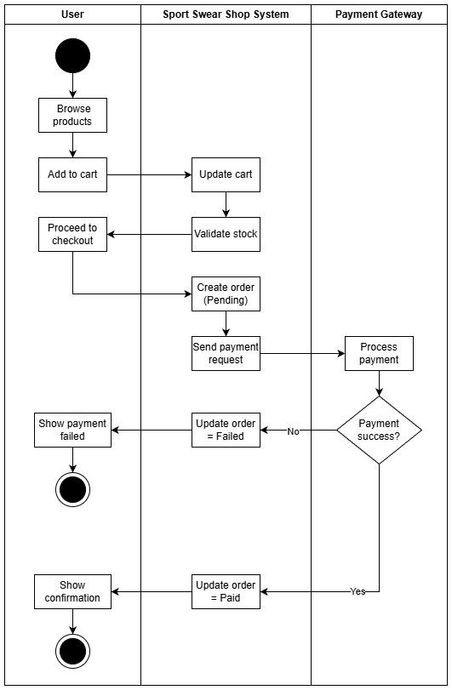

6.2 Chatbot AI
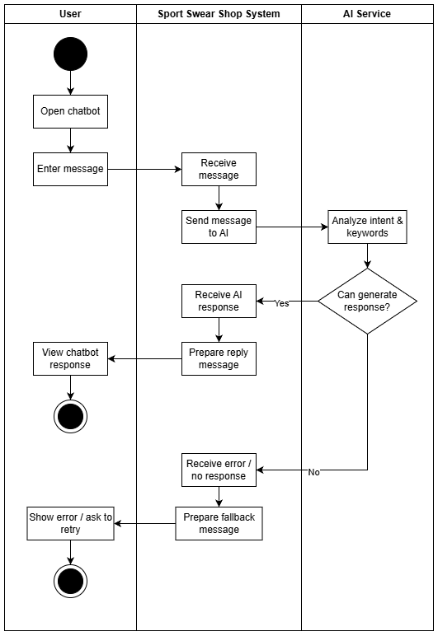

6.3 Order Status Tracking
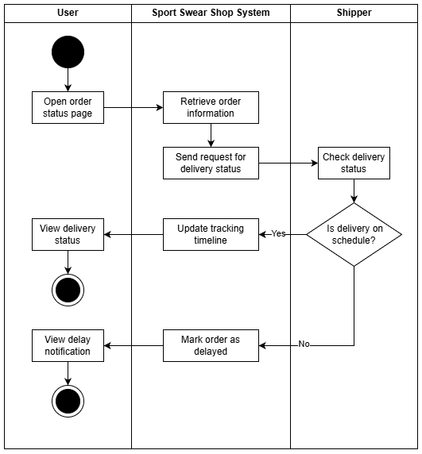

6.4 Product Review
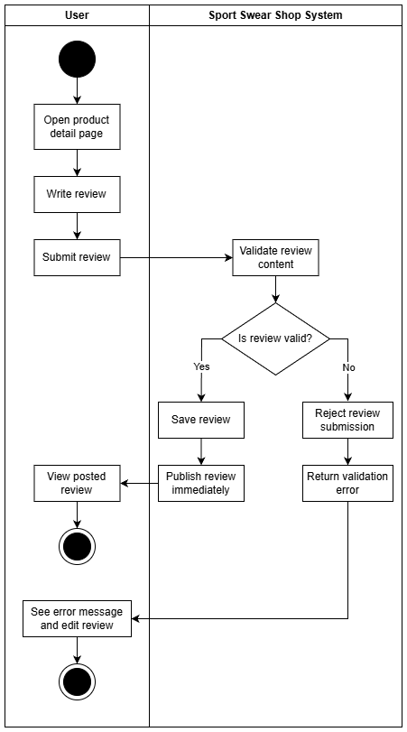

6.5 Summary of Reports & Statistics
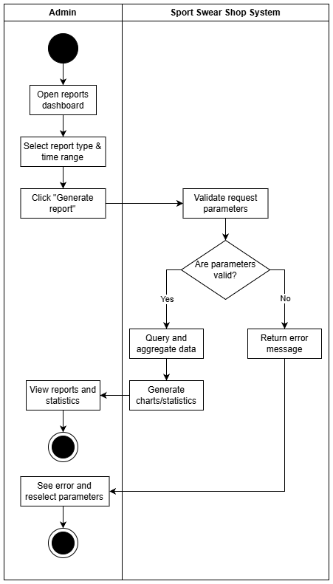

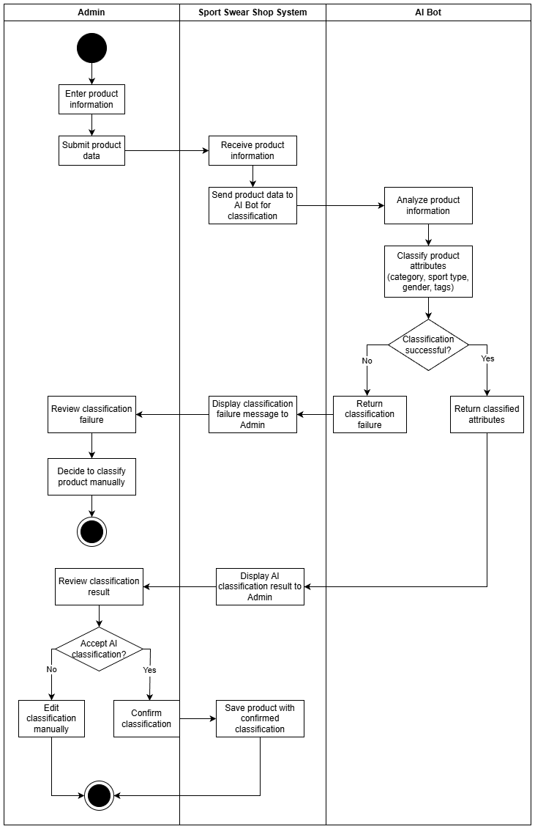
6.6
AI Product Classification

7. Static Modeling
7.1 Conceptual ERD: show entities and relationships.
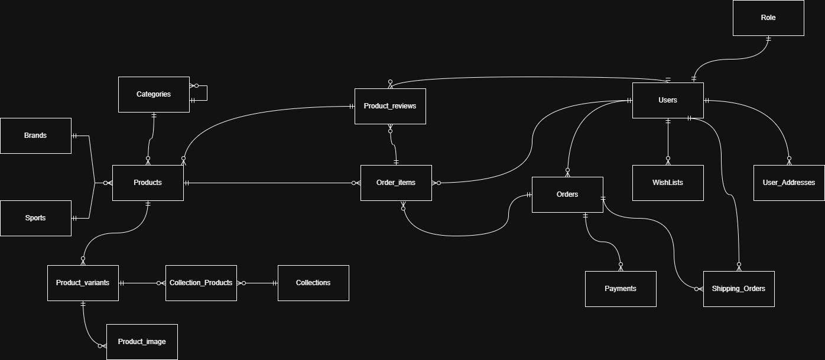
7.2 Class Diagram:

8. Database design
- Show database diagram
- Data dictionary

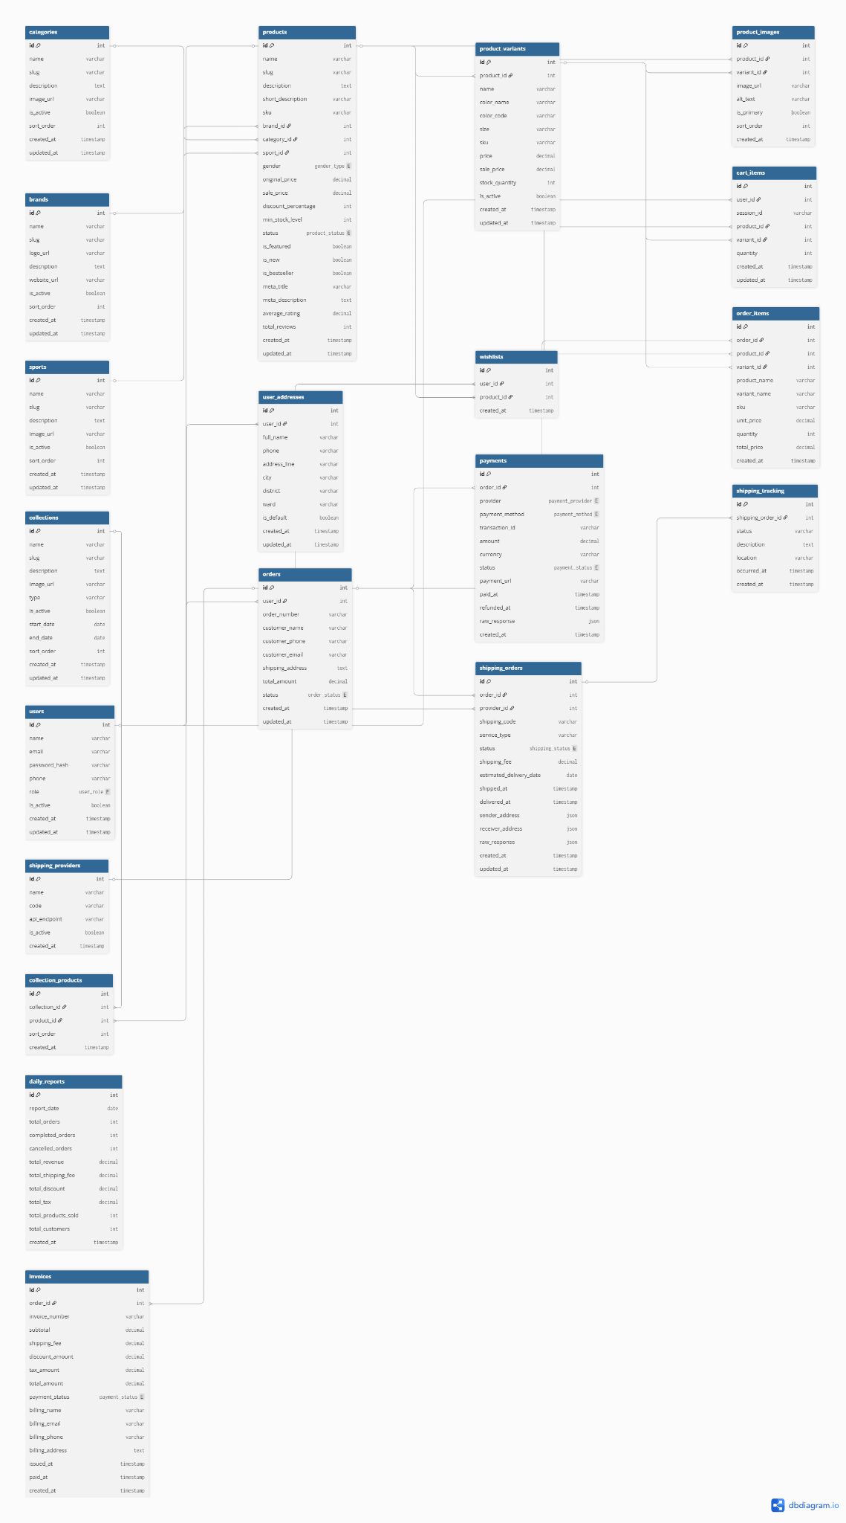

9. Dynamic Modeling
- Sequence Diagram(s):
- Purchase Management
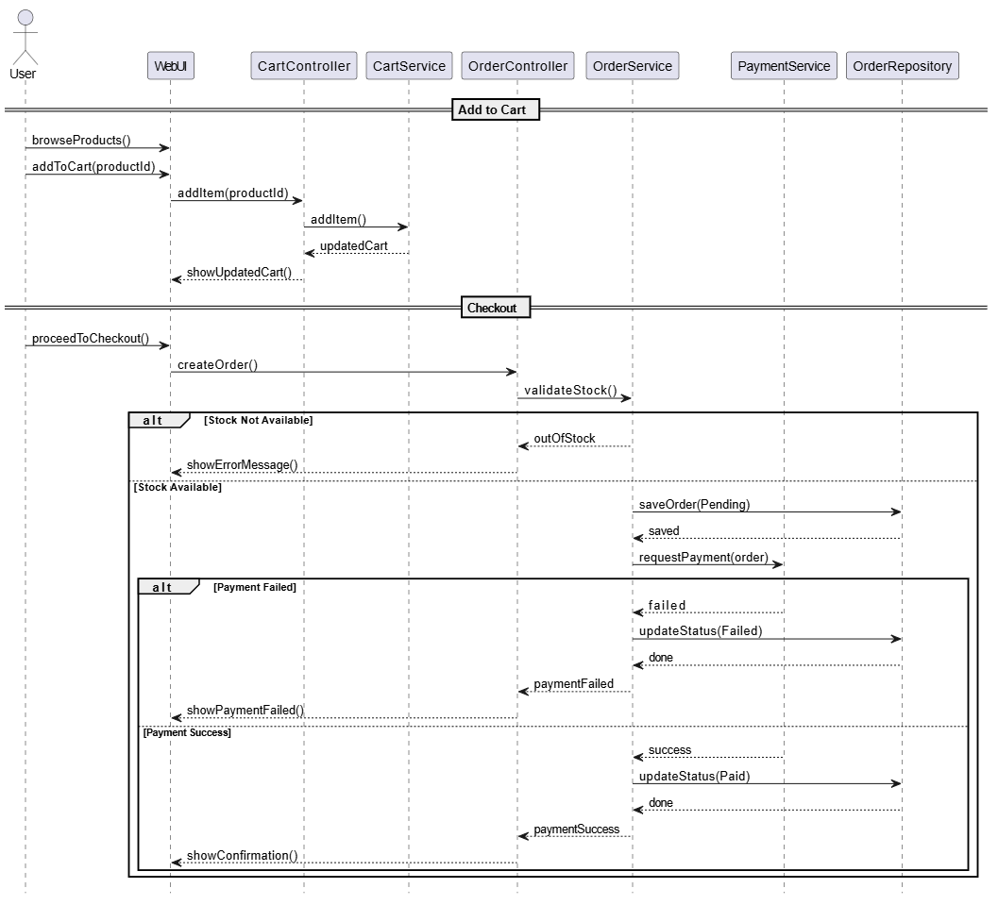
- Chatbot AI
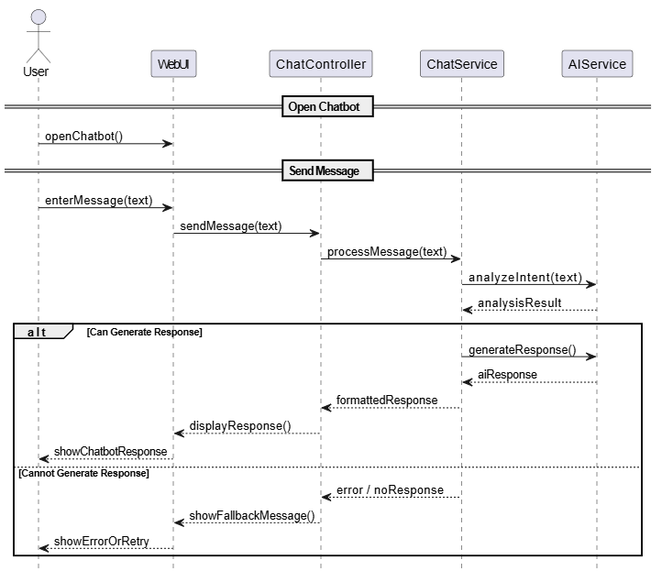
- Order Status Tracking
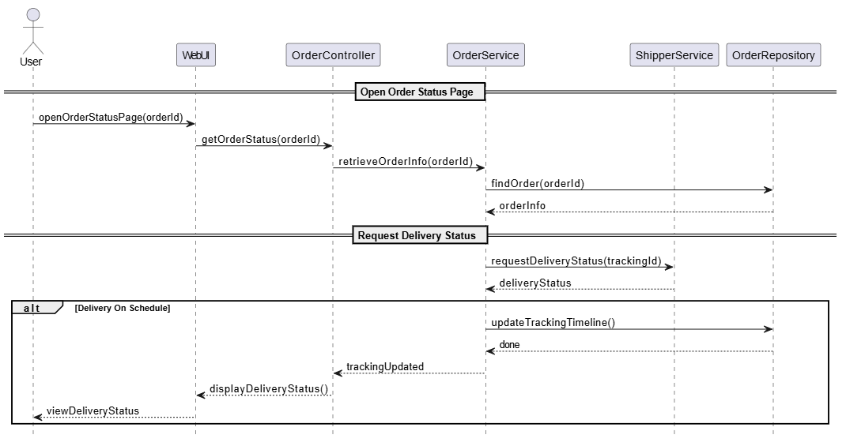
- Product Review
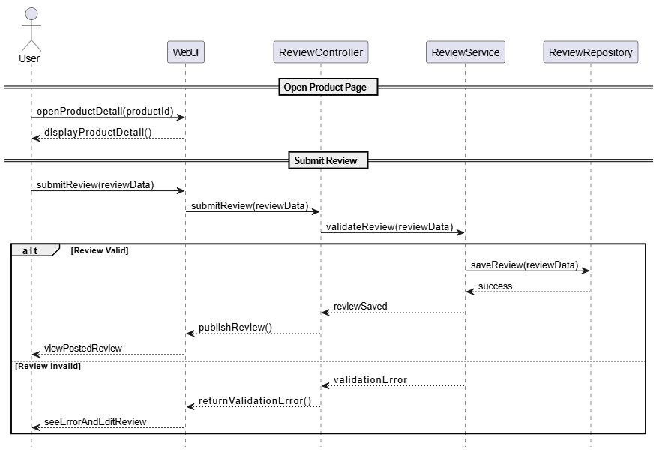
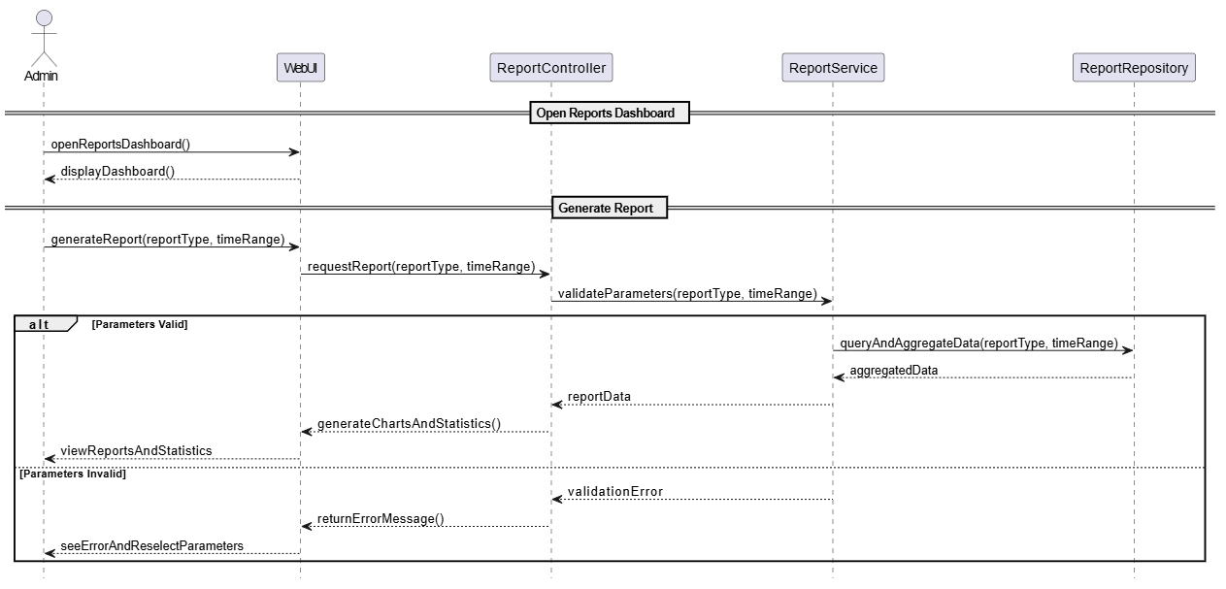
- Summary of Reports & Statistics

- AI Product Classification
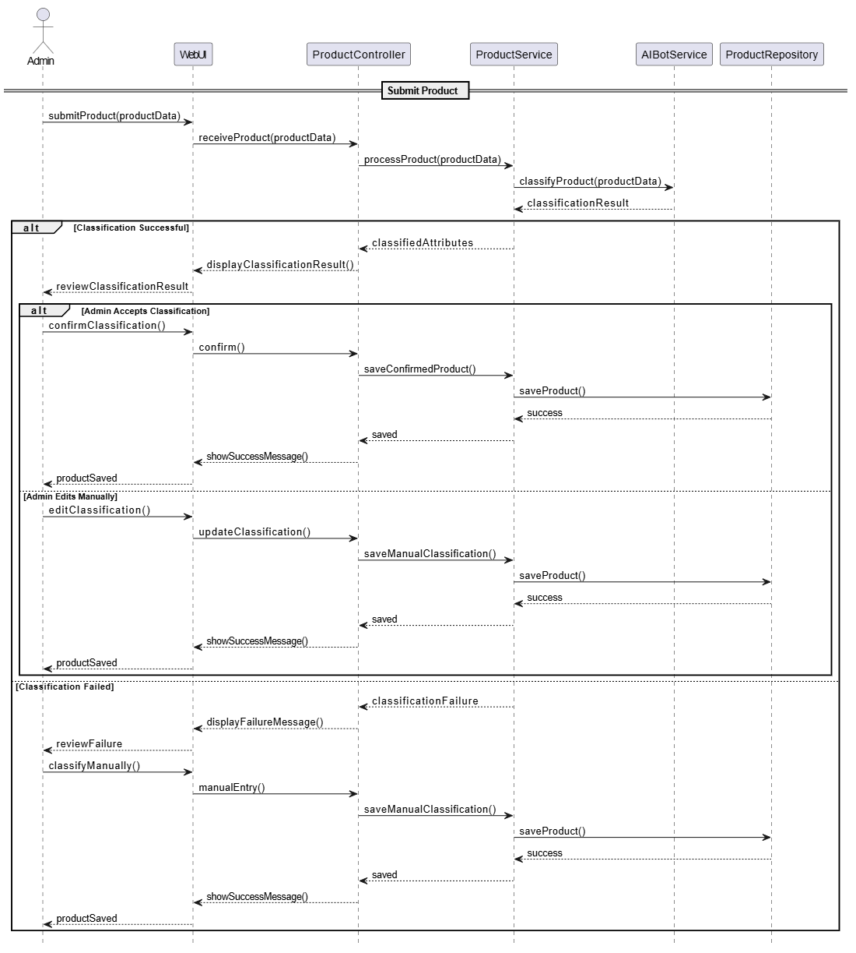
- State Machine Diagram: For classes with important states (e.g., Order, User Session).

10. Product

11. Test cases
(Use template on LMS)
12. Conclusion
- Summary: Recap the main design results.
- Limitations: State current constraints or trade-offs.
- Future Work: Suggest improvements or next steps.
13. AI Appendix (Phụ lục sử dụng AI)
13.1. Declaration of Tools
List the specific AI tools used during the project lifecycle.
· Tool Name: Gemini (Google) or GitHub Copilot.
· Version/Model: e.g., "Gemini 2.5 Flash"
· Purpose: Summarize the role (e.g., "Code debugging, Java class generation, documentation assistance").
13.2. Scope of Use
Describe exactly where and how the AI was integrated. For your current e-commerce project, this might look like:
· Architecture & Logic: "Used AI to brainstorm the DTO (Data Transfer Object) and DAO (Data Access Object).
· Bug Fixing: "Assisted in resolving Ant build errors and Maven dependency conflicts in the W1 project environment."
13.3. Prompt Log (Sample)
Include a table or list showing a few key prompts and the AI's response to demonstrate the iterative process.
Task | Prompt Used | Action Taken on Output
DAO Implementation | "Create an AccountDAO.java using JDBC for a login function." | Modified the generated code to match the com.team6.ecommercesystem package structure.
Error Handling | "Fix 'Build failed' error in Ant for Java Web project W1." | Followed the suggested path configuration for the local server.

13.4. Statement of Responsibility
A brief paragraph confirming that you reviewed and verified all AI-generated content.
"All code and documentation generated with the assistance of AI tools were manually reviewed, tested, and integrated by the author. Logic was adjusted to ensure compatibility with the Team 6 project architecture and security standards."

